# Slot5 – Ex1

# [Healthy Recipe Finder](http://localhost:3000/#home)

## NavbarComponent.js



import React from 'react';

import { Navbar, Nav, Button, Container } from 'react-bootstrap';

const NavbarComponent = () => (

    <Navbar bg="light" expand="lg" className="mb-4" style={{ backgroundColor: '#F5F6F2' }}>

        <Container fluid>

            <Navbar.Brand href="#home" className="fw-bold">

                Healthy Recipe Finder

            </Navbar.Brand>

            <Navbar.Toggle aria-controls="basic-navbar-nav" />

            <Navbar.Collapse id="basic-navbar-nav">

                <Nav className="mx-auto" style={{ color: '#094f3e'}}>

                    <Nav.Link href="#home" active>Home</Nav.Link>

                    <Nav.Link href="#about">About</Nav.Link>

                    <Nav.Link href="#recipes">Recipes</Nav.Link>

                </Nav>

                <div className="d-flex">

                    <Button variant="custom" style={{ backgroundColor: '#203933', color: 'white', borderColor: '#203933' }}>Browse Recipes</Button>

                </div>

            </Navbar.Collapse>

        </Container>

    </Navbar>

);

export default NavbarComponent;

## Footer.js



import React from 'react';

import { Container, Row, Col } from 'react-bootstrap';

const Footer = () => (

  <footer className="bg-light text-center py-3 mt-4" style={{ backgroundColor: '#F5F6F2' }}>

    <Container>

      <Row>

        <Col>

          <p className="mb-0">Made with ❤️ and 🍳</p>

        </Col>

      </Row>

    </Container>

  </footer>

);

export default Footer;

## Hero.js

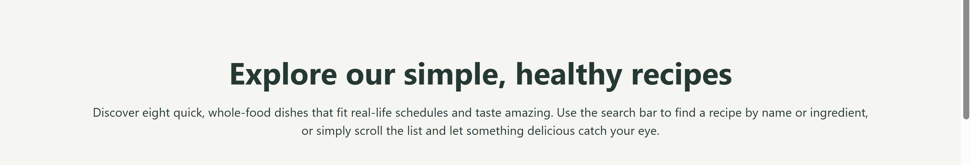

import React from 'react';

const Hero = () => (

  <div className="text-center py-5" style={{

    backgroundColor: '#F5F6F2',

    padding: '30px 20px',

    borderRadius: '10px'

  }}>

    <h1 className="fw-bold mb-3" style={{

      fontSize: '2.5rem',

      color: '#203933'

    }}>

      Explore our simple, healthy recipes

    </h1>

    <p className="mb-0" style={{

      fontSize: '1rem',

      color: '#203933'

    }}>

      Discover eight quick, whole-food dishes that fit real-life schedules and taste amazing. Use the search bar to find a recipe by name or ingredient, or simply scroll the list and let something delicious catch your eye.

    </p>

  </div>

);

export default Hero;

## Filters.js

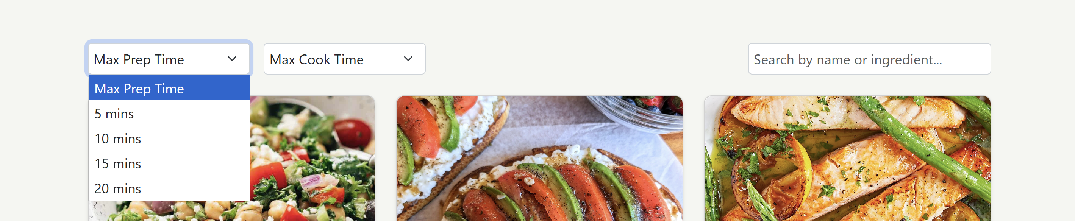

import React, { useState, useEffect } from 'react';

import { Form } from 'react-bootstrap';

const Filters = ({ onFilter }) => {

  const [maxPrep, setMaxPrep] = useState(0);

  const [maxCook, setMaxCook] = useState(0);

  const [searchTerm, setSearchTerm] = useState('');

  useEffect(() => {

    const handler = setTimeout(() => {

      onFilter({ maxPrep, maxCook, searchTerm });

    }, 300);

    return () => clearTimeout(handler);

  }, [maxPrep, maxCook, searchTerm, onFilter]);

  return (

    <Form className="d-flex justify-content-between mb-4">

      <div className="d-flex">

        <Form.Select

          className="me-3"

          value={maxPrep}

          onChange={(e) => setMaxPrep(parseInt(e.target.value) || 0)}

          style={{ width: '200px', borderRadius: '5px', border: '1px solid #ced4da', padding: '6px' }}

        >

          <option>Max Prep Time</option>

          <option value="5">5 mins</option>

          <option value="10">10 mins</option>

          <option value="15">15 mins</option>

          <option value="20">20 mins</option>

        </Form.Select>

        <Form.Select

          value={maxCook}

          onChange={(e) => setMaxCook(parseInt(e.target.value) || 0)}

          style={{ width: '200px', borderRadius: '5px', border: '1px solid #ced4da', padding: '6px' }}

        >

          <option>Max Cook Time</option>

          <option value="5">5 mins</option>

          <option value="10">10 mins</option>

          <option value="15">15 mins</option>

          <option value="20">20 mins</option>

        </Form.Select>

      </div>

      <Form.Control

        type="text"

        placeholder="Search by name or ingredient..."

        value={searchTerm}

        onChange={(e) => setSearchTerm(e.target.value)}

        style={{ width: '300px', borderRadius: '5px', border: '1px solid #ced4da', padding: '6px' }}

      />

    </Form>

  );

};

export default Filters;

## RecipeGrid.js

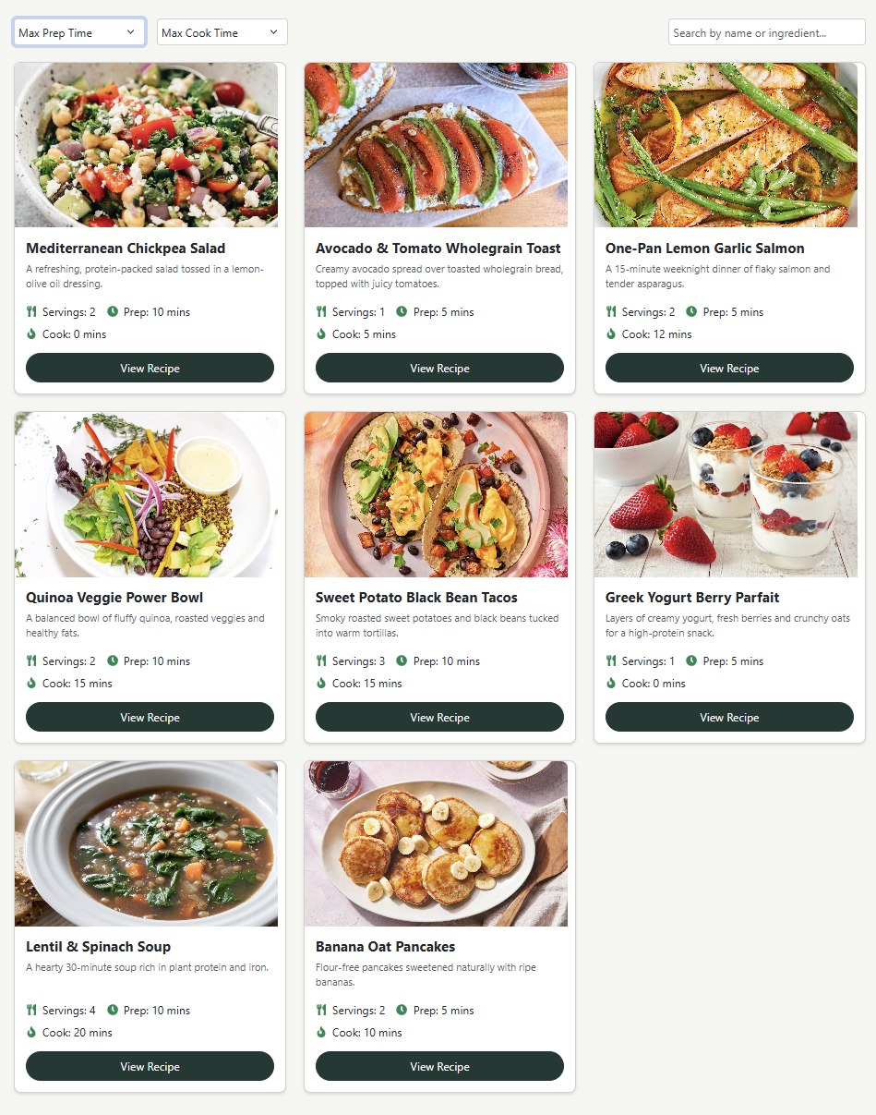

import React from 'react';

import RecipeCard from './RecipeCard';

const RecipeGrid = ({ recipes, onView }) => (

  <div className="row">

    {recipes.map((recipe, index) => (

      <div key={index} className="col-12 col-sm-6 col-md-4 mb-4">

        <RecipeCard recipe={recipe} onView={onView} />

      </div>

    ))}

  </div>

);

export default RecipeGrid;

## RecipeCard.js

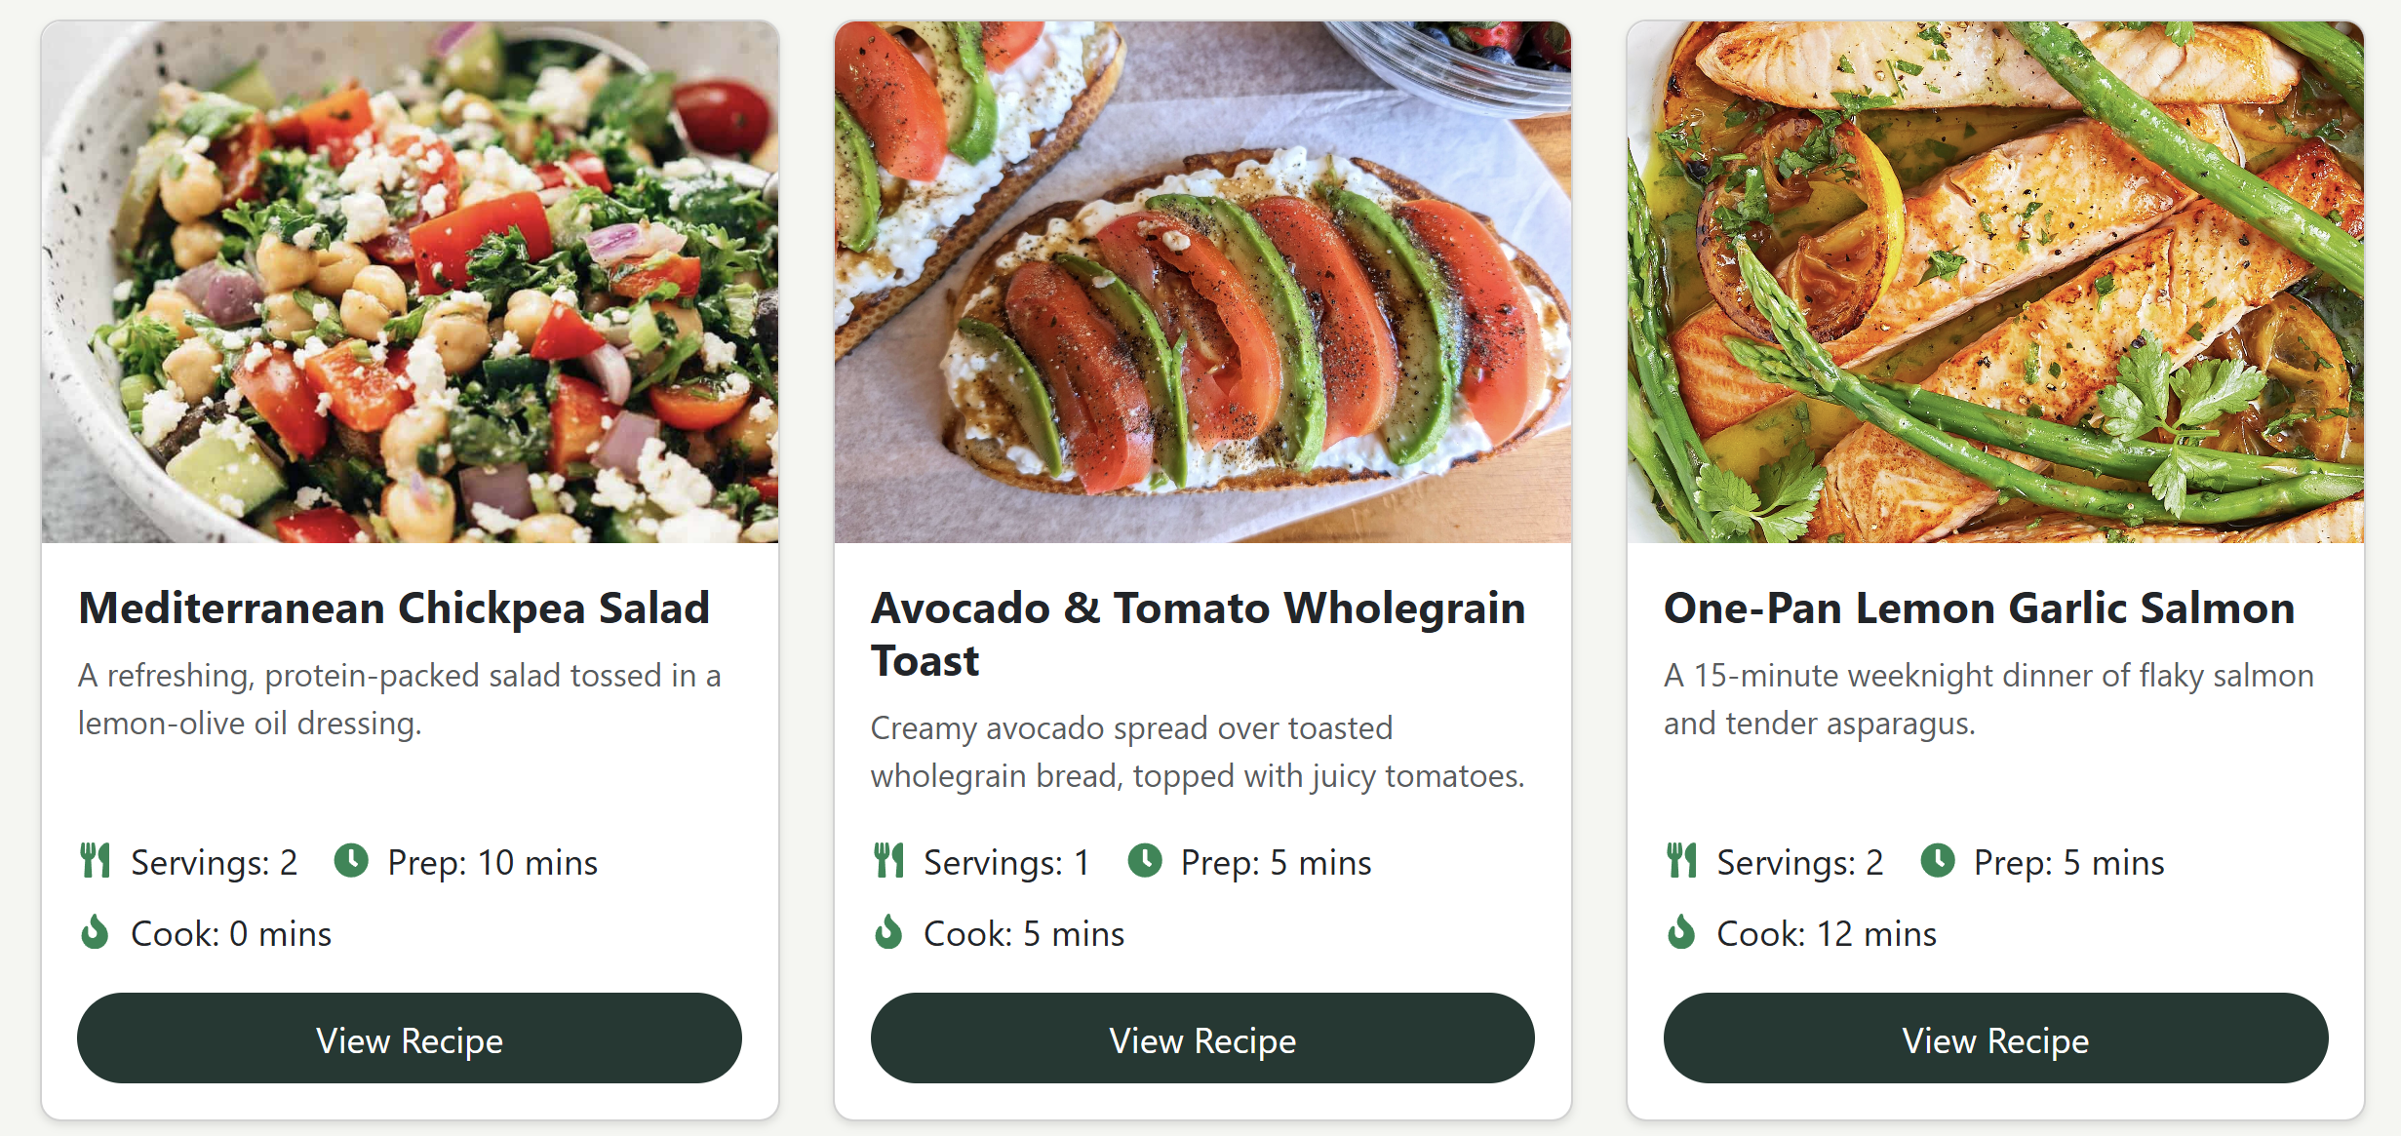

import React from 'react';

import { Card, Button } from 'react-bootstrap';

import { FaUtensils, FaClock, FaFire } from 'react-icons/fa';

const RecipeCard = ({ recipe, onView }) => (

  <Card style={{

    maxWidth: '450px',

    margin: '0 auto',

    borderRadius: '10px',

    overflow: 'hidden',

    boxShadow: '0 2px 4px rgba(0,0,0,0.1)',

    height: '100%'

  }}>

    <Card.Img

      variant="top"

      src={recipe.image}

      style={{

        width: '400px',

        height: '250px',

        objectFit: 'cover',

        borderTopLeftRadius: '10px',

        borderTopRightRadius: '10px'

      }}

    />

    <Card.Body className="d-flex flex-column p-3" style={{ height: '100%' }}>

      <Card.Title className="text-dark fw-bold mb-2 flex-shrink-0">

        {recipe.title}

      </Card.Title>

      <Card.Text className="text-muted mb-3 flex-grow-1" style={{ fontSize: '0.9rem' }}>

        {recipe.description}

      </Card.Text>

      <div className="d-flex align-items-center mb-2">

        <FaUtensils className="text-success me-2" />

        <span className="me-3">Servings: {recipe.servings}</span>

        <FaClock className="text-success me-2" />

        <span>Prep: {recipe.prep} mins</span>

      </div>

      <div className="d-flex align-items-center mb-3">

        <FaFire className="text-success me-2" />

        <span>Cook: {recipe.cook} mins</span>

      </div>

      <Button

        variant="custom"

        onClick={() => onView(recipe)}

        style={{

          backgroundColor: '#203933',

          color: 'white',

          borderColor: '#203933',

          width: '100%',

          padding: '8px',

          borderRadius: '26px',

          flexShrink: 0

        }}

      >

        View Recipe

      </Button>

    </Card.Body>

  </Card>

);

export default RecipeCard;

## App.js

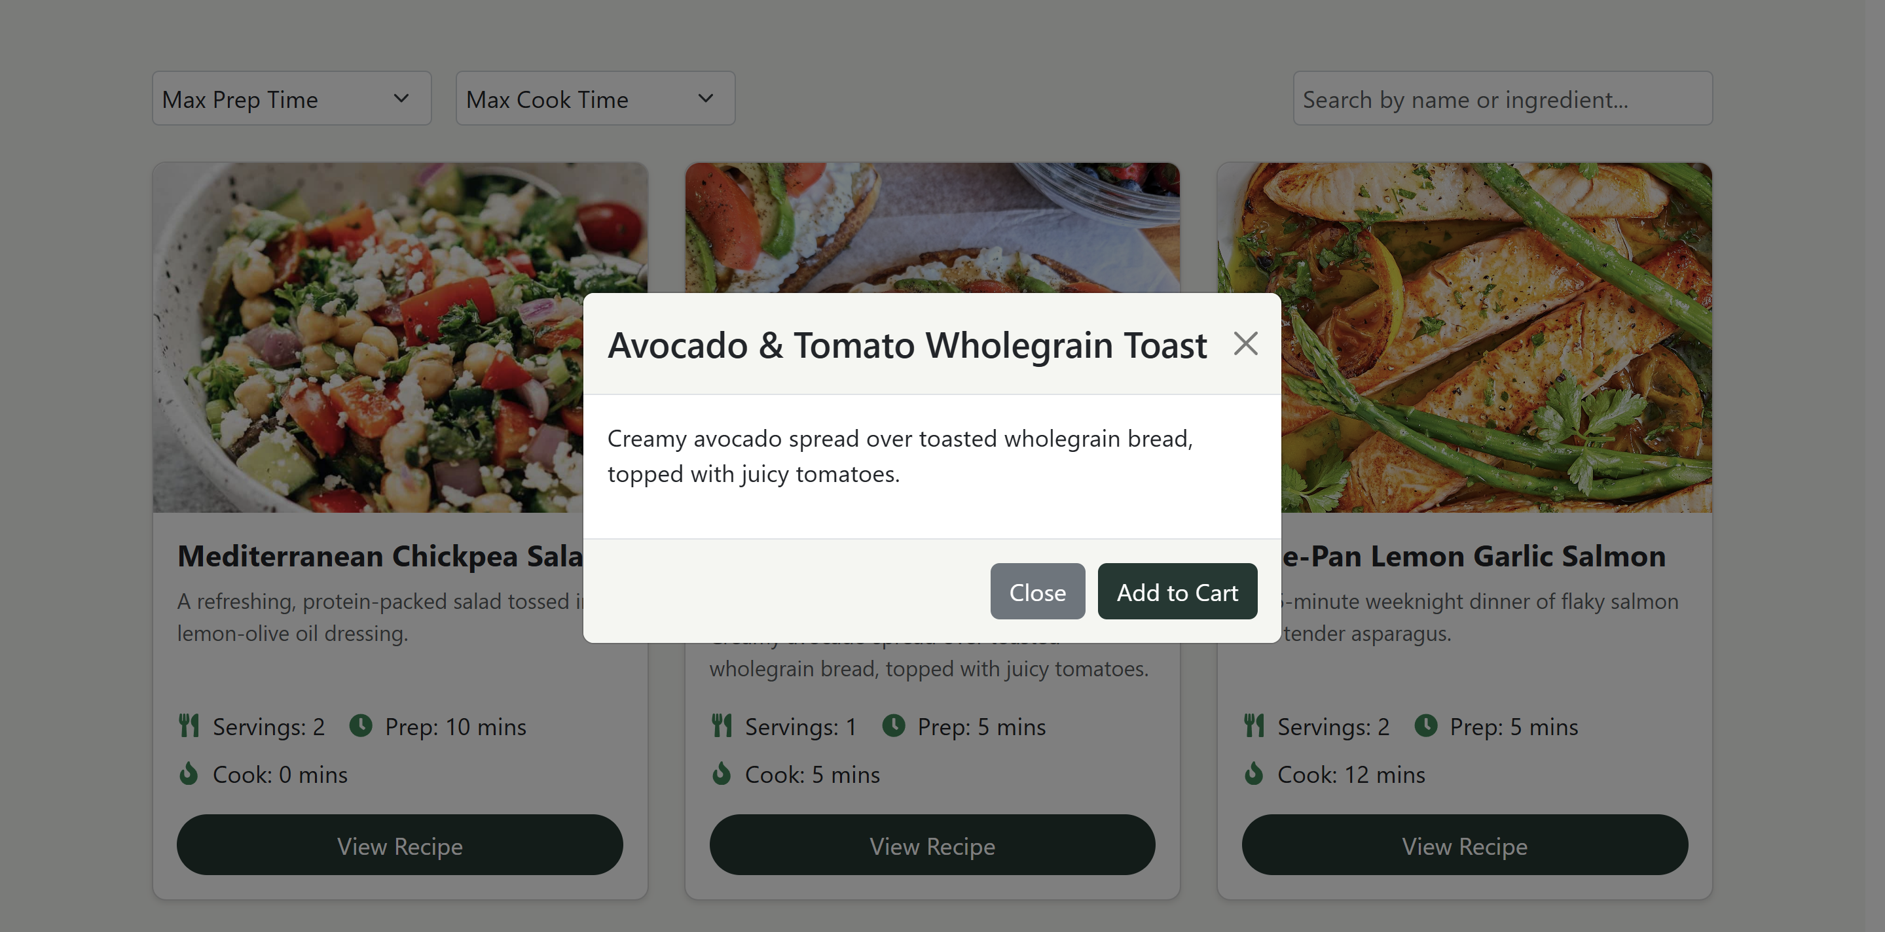

import React, { useState } from 'react';

import { Container, Modal, Button } from 'react-bootstrap'; // Thêm Button

import NavbarComponent from './components/Navbar';

import Hero from './components/Hero';

import Filters from './components/Filters';

import RecipeGrid from './components/RecipeGrid';

import Footer from './components/Footer';

import recipes from './recipes';

function App() {

  const [filteredRecipes, setFilteredRecipes] = useState(recipes);

  const [selectedRecipe, setSelectedRecipe] = useState(null);

  const handleFilter = ({ maxPrep, maxCook, searchTerm }) => {

    const filtered = recipes.filter(recipe =>

      (recipe.title.toLowerCase().includes(searchTerm.toLowerCase()) || recipe.description.toLowerCase().includes(searchTerm.toLowerCase())) &&

      (maxPrep === 0 || recipe.prep <= maxPrep) &&

      (maxCook === 0 || recipe.cook <= maxCook)

    );

    setFilteredRecipes(filtered);

  };

  const handleViewRecipe = (recipe) => setSelectedRecipe(recipe);

  const handleCloseModal = () => setSelectedRecipe(null);

  return (

    <div style={{ backgroundColor: '#F5F6F2', minHeight: '100vh' }}>

      <NavbarComponent />

      <Container>

        <Hero />

        <Filters onFilter={handleFilter} />

        <RecipeGrid recipes={filteredRecipes} onView={handleViewRecipe} />

      </Container>

      <Footer />

      <Modal show={!!selectedRecipe} onHide={handleCloseModal} centered>

        <Modal.Header closeButton style={{ backgroundColor: '#F5F6F2' }}>

          <Modal.Title>{selectedRecipe?.title}</Modal.Title>

        </Modal.Header>

        <Modal.Body>

          <p>{selectedRecipe?.description}</p>

        </Modal.Body>

        <Modal.Footer style={{ backgroundColor: '#F5F6F2' }}>

          <Button variant="secondary" onClick={handleCloseModal}>Close</Button>

          <Button variant="custom" style={{ backgroundColor: '#203933', color: 'white', borderColor: '#203933' }}>Add to Cart</Button>

        </Modal.Footer>

      </Modal>

    </div>

  );

}

export default App;